**1.PROBLEM**

**Lists - images**

"Creators Edge" Web Designers have been signed up by Pink Frag Events Organizer for redesigning their official website to be on pair with the trending technologies. The creative team of the web designers had a discussion and planned to form a young team for designing. The young team's first task is to change the bulleted icons into different images using certain CSS properties.  
  
Hence the firm has appointed you as part of their creative team and assigned you the task of creating a webpage which would display the available events list using the list-style-image property in CSS.

**Hints :**

**list-style-image property**

The list-style-image property replaces the list-item marker with an image.

Syntax :

list-style-image: none|*url*|initial|inherit;

**Content :**  
h1 -Pink Frag Event Organizer  
<hr>  
h3 - Wedding Events  
ul class - "wedding"  
li  
Photography  
Music band  
Henna artist  
Beautician  
  
h3 - Corporate Events  
ul class - "corporate"  
 li  
Grand Openings  
Seminars  
Meetings  
Team Building  
  
h3 - Social Events  
ul class - "social"  
li  
Birthday party  
Surprise party  
Dinner party  
Garden party  
  
Use  list-style-image property for bullet as image.  
There should not be 'style' attribute in the ul tag  
  
In ul tag with class wedding  
Give list-style-image as circle.png  
  
In ul tag with class corporate  
Give list-style-image as square.png  
  
In ul tag with class social  
Give list-style-image as star.png  
  
**Constraints :**  
Tag 'ul' must be present for minimum of 3 times in the html page.  
Tag 'li' must be present for minimum of 4 times inside each <ul> tag in the html page.  
Refer screenshots for html specifications.  
The list-style-image should be the same as given in the problem content.  
  
**Note :**  
Content of the page should be present as shown in the screenshot.  
Kindly refer the content which is given as a part of description.  
  
**Sample Screenshot 1 :**  
  
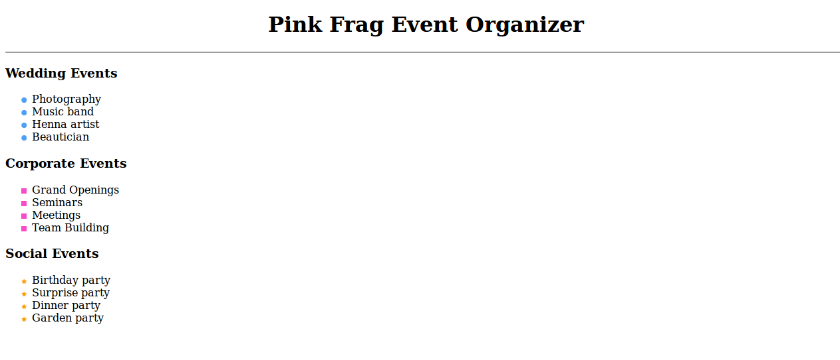

2. HTML Ordered Lists - 3

“GoldenPetal Events” Company has been booked for a big event by the Consumers Welfare Society to organize a mega Consumer Fair that is the most effective and economical platform for small industries for marketing.  In connection to the event, the company wanted to print advertisement pamphlets to be distributed at the Event venue to promote their brand name.  
  
The pamphlets should be designed with an ordered list to list down all the events. They key thing here is that in between the ordered list, few descriptions regarding the events should be displayed and the ordered list should resume back after the descriptions with appropriate numbering.  
  
Write an html program to create a html page using ordered list with numbers using <ol> and <p> tags.  

Hints :

Tag <ol>

The <ol> tag defines an ordered (numbered) list.

Syntax :

<ol>...</ol>

Tag <li>

The <li> tag is used in ordered lists(<ol>), unordered lists (<ul>), and in menu lists (<menu>).

Syntax :

<li>...</li>

Content :  
The start of the first ol is decimal numbers (1, 2, 3, 4)  
li tag - Bridal party  
li tag - Engagement parties  
li tag - Caterer  
li tag - Wedding ceremony  
  
p tag - You can't imagine your wedding day without your best friends. So read our advice on how to choose your bridesmaids and groomsmen, get their duties in detail, and new bridesmaid and groomsmen gift ideas. Plus, read all you need to know about casting your very important extras -- from the flower girl to the ushers, readers, and candlelighters.  
  
p tag - One of the most personal and important aspects of your wedding planning process will be choosing your wedding party! Your wedding party (also known as the bridal party) will include not only the people who will help you plan your big day, but they also are those you will want by your side when you walk down the aisle and say your vows. Typically your wedding party is made up of your sisters, brothers and closest friends or family members.This page will serve as a guide to share all of the duties, roles and responsibilities that are involved for each participant of the wedding party. Each individual member of the wedding party has unique responsibilities, so click on each of the roles below to read thorough explanations of those duties.  
  
The start of the second ol is decimal numbers (5,6,7)  
li tag - Seminars and Conferences  
li tag - Appreciation Events  
li tag - Team Building Events  
  
p tag - An engagement party is a party held to celebrate a couple's recent engagement and to help future wedding guests to get to know one another. Traditionally, the bride's parents host the engagement party, but many modern couples host their own celebration.  
  
Constraints :  
Tag 'ol' must be present minimum 2 times in the html page.  
Tag 'li' must be present minimum 7 times in the html page.  
Tag 'p' must be present minimum 3 times in the html page.  
The Content in the tags should be the same as given in the problem content.  
  
Note :  
Content of the page should be present as shown in the screenshot.  
Kindly refer the content which is given as a part of description.  
  
Sample Screenshot 1 :  
  
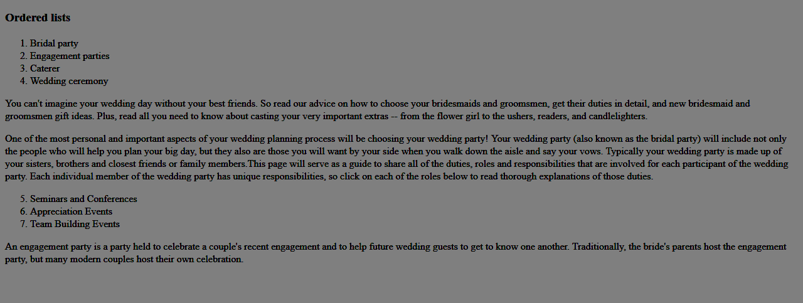

3. HTML - ul symbols

Four Feathers Events Services is an event management Company who has continuously strived towards the flawless execution of events.  The company has an all-in-one event management platform that enables to impeccably manage event from beginning to end within one system. In the existing home page of the company’s website, the Supported Events (Common Events) are listed using unordered (bulleted) lists and the Corporate Events are listed using an ordered (numbered) list. Your Manager wanted to redesign the page in such a way that the Common Events will have circled bullet points and the Corporate Events will have square bullet points.  
  
Write a program to create an html page that will display the Common Events with circled bullet points and the Corporate Events with square bullet points.

Hints :

Tag <ul>

The <ul> tag defines an unordered (bulleted) list.

Syntax :

<ul>...</ul>

Tag <li>

The <li> tag is used in ordered lists(<ol>), unordered lists (<ul>), and in menu lists (<menu>).

Syntax :

<li>...</li>

type attribute

The type attribute specifies the kind of marker to use in the unordered list.

Syntax :

<ul type="disc|circle|square">

Content :  
h1 - Event Schedule List  
  
div  id - CommonEvents  
h2 - Supported Events  
ul list  
li - Concerts  
li - Conferences  
li - Films  
li - Panel Debates  
li - Performances  
li - Seminars  
li - Talks & Discussions  
li - Workshops  
  
div  id - CorporateEvents  
h2 - Corporate Events  
ul list  
li - Team Building Events  
li - Trade Shows  
li - Business Dinners  
li - Networking Events  
li - Opening Ceremonies  
li - Product Launches2018  
li - Theme Parties  
li - Shareholder Meetings  
  
list in CommonEvents div should have circle bullet points  
list in CorporateEvents div should have squarebullet points  
Use  type attribute in the ul for having different bullet points  
  
Constraints :  
Tag 'ul' must be present minimum 2 times in the html page.  
Tag 'li' must be present minimum 8 times in the html page.  
The div tag with id must be present in the html page as given in the content.  
The headers should be same as as given in the content.  
The Content in the tags should be the same as given in the problem content.  
  
Note :  
Content of the page should be present as shown in the screenshot.  
Kindly refer the content which is given as a part of description.  
  
Sample Screenshot 1 :  
  
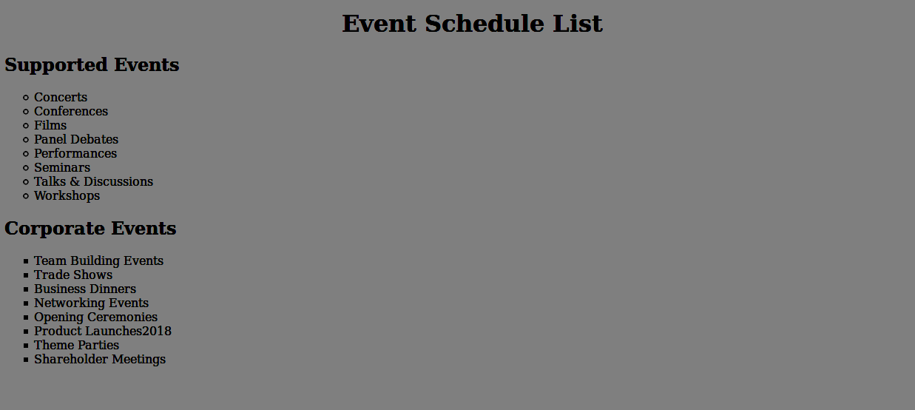

4.HTML Ordered Lists - 2

Four Feathers Events Services has an all-in-one event management platform that enables to impeccably manage the event from beginning to end within one system.  
In the existing home page of the company’s website, the Supported Events (Common Events) are listed using unordered (bulleted) lists and the Corporate Events are listed using an ordered (numbered) list. Your Manager wanted to redesign the page in such a way that the Common Events will have lowercase letters for numbering and the Corporate Events will have lowercase roman numbers.  
  
Write a program to create an html page that will display the Common Events with lowercase letters for numbering and the Corporate Events with lowercase roman numbers.

Hints :

Tag <ol>

The <ol> tag defines an ordered (numbered) list.

Syntax :   <ol>...</ol>

Tag <li>

The <li> tag is used in ordered lists(<ol>), unordered lists (<ul>), and in menu lists (<menu>).

Syntax :   <li>...</li>

type attribute

The type attribute specifies the kind of marker to use in the unordered list.

Syntax :   <ol type="disc|circle|square">

Content :  
h1 - Event Schedule List  
  
div  id -CommonEvents  
h2 - Supported Events  
ol list  
Concerts  
Conferences  
Films  
Panel Debates  
Performances  
Seminars  
Talks & Discussions  
Workshops  
  
div  id - CorporateEvents  
h2 - Corporate Events  
ol list  
Team Building Events  
Trade Shows  
Business Dinners  
Networking Events  
Opening Ceremonies  
Product Launches2018  
Theme Parties  
Shareholder Meetings  
  
list in CommonEvents div should have lowercase letters as numbering  
list in CorporateEvents div should have lowercase roman numbers  
Use type attribute in the ol for having different bullet points  
  
Constraints :  
Tag 'ol' must be present minimum 2 times in the html page.  
Tag 'li' must be present minimum 16 times in the html page.  
The div tag with id must be present in the html page as given in the content.  
The headers should be same as as given in the content.  
The Content in the tags should be the same as given in the problem content.  
  
Note :  
Content of the page should be present as shown in the screenshot.  
Kindly refer the content which is given as a part of description.  
  
Sample Screenshot 1 :  
  
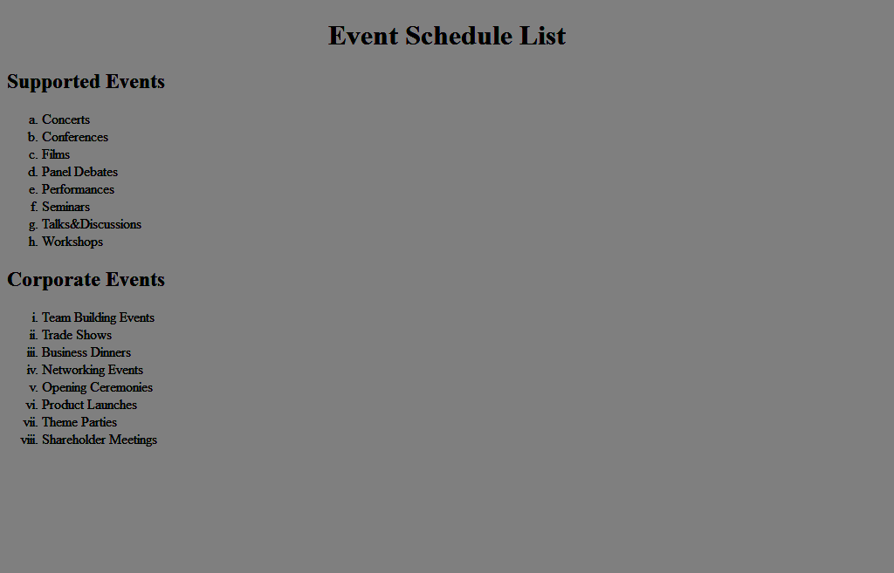

5. HTML - description list

“Pink Frag Events” Company has booked by its Corporate Client, Caroltech Solutions for a Business Conference. In connection to the event, the Pink Frag Company Management wanted to print few display boards to placed at the Event venue which is a proven method of success and the best way of catching people’s attention.  
  
To develop the content for the display board the event company decided to list and describe in short about the kinds of events they organize for the corporate clients. Write a program for creating an html page using the description list tags.

Hints :

Tag <dl>

The <dl> tag defines a term/name in a description list. The <dl> tag is used in conjunction with <dt> (defines terms/names) and <dd> (describes each term/name).

Syntax :

<dl> <dt>...<dt> </dl>

Content :  
dt - Conference  
dd - Conferences are popular and important business events. Everything about the event management of academic, medical and business conferences  
dt - Seminar  
dd- Seminars educational events for the training of managers and employees. Most seminars are not comparable with boring lectures. Interactivity is core!  
dt - Meeting  
dd - Meetings are common business events in large companies, perfect to discuss operational and financial strategies  
  
Content :  
Tag dl must be used.  
Tag dt must be present mimimum 3 times.  
The dd tag must be present within each dt tag.  
  
Note :  
Content of the page should be present as shown in the screenshot.  
Kindly refer the content which is given as a part of description.  
  
Sample Screenshot 1 :  
  
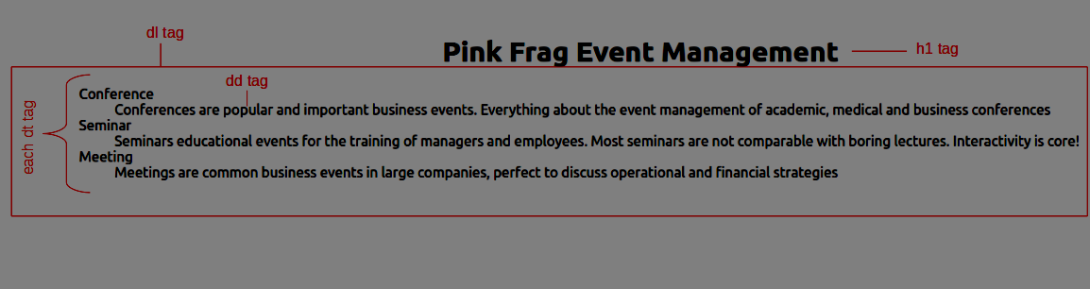

6. HTML - nested list

“Golden Petal Events” Company has been booked for a big event by the Consumers Welfare Society to organize a mega Consumer Fair that is the most effective and economical platform for small industries for marketing.  In connection to the event, the company wanted to print advertisement pamphlets to be distributed at the Event venue to promote their brand name.  
  
The pamphlets should be designed to list down all the events serviced by the company. The list should be a nested list, with Main Events and the Supporting Events under each Main event.  
  
Write an html program to output a nested list in the pamphlets of the company.

Hints :

Tag <ul>

The <ul> tag defines an unordered (bulleted) list.

Syntax :

<ul>...</ul>

Tag <ol>

The <ol> tag defines an ordered list.

Syntax :

<ol>...</ol>

Tag <li>

The <li> tag is used in ordered lists(<ol>), unordered lists (<ul>), and in menu lists (<menu>).

Syntax :

<li>...</li>

Nested list:

An individual list item can contain another entire list, called a nested list.

Syntax :

 <ol>

  <li>

    <ul>

      <li>.....</li>

      <li>......</li>

    </ul>

  </li>

  <li>

<ol>

      <li>.....</li>

      <li>......</li>

    </ol>

  </li>

</ol>

Content :  
  The type of the first ol is uppercase roman numbers (I, II, III, IV ,V) and the start of all the inner ol is decimal numbers (1, 2, 3, 4 , 5)  
   <h2> - Nested list  
   <li> - Wedding  
   <li> - Bridal party  
   <li> - Engagement parties  
   <li> - Caterer  
   <li> - Wedding ceremony  
   <li> - Wedding reception  
   <li> - Corporate  
   <li> - Seminars and Conferences  
   <li> - Appreciation Events  
   <li> - Team Building Events  
   <li> - Product Launch Events  
   <li> - Shareholder Meetings  
   <li> - Exhibition  
   <li> - Aerophilately  
   <li> - Astrophilately  
   <li> - Fight against Forgeries  
   <li> - Maximaphily  
   <li> -Philatelic literature  
   <li> -Trade Shows       
   <li> - Argentina  
   <li> -Bolivia  
   <li> -Brazil  
   <li> -Canada  
   <li> -Chile  
   <li> -Stage Events  
   <li> -Birthday party  
   <li> -Surprise party  
   <li> -Dinner party  
   <li> -Garden party  
   <li> -Cocktail party  
  
  <b> - Wedding, Corporate, Exhibition, Trade Shows, Stage Events  
  
Constraints :  
Tag 'ol' must be present minimum 6 times in the html page.  
Tag 'li' must be present minimum 30 times in the html page.  
The Content in the tags should be the same as given in the problem content.  
  
Note :  
Content of the page should be present as shown in the screenshot.  
Kindly refer the content which is given as a part of description.  
  
Sample Screenshot 1 :  
  
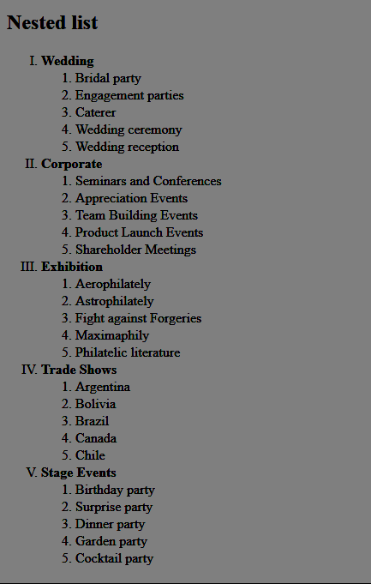  
  
  
  
7. HTML Ordered Lists

Panta figs Events Services has an all-in-one event management platform that enables to impeccably manage event from beginning to end within one system. Yaserkhan, the Creative Team Head wanted you to redesign their official web page in such a way that the Supported Events are numbered using odd numbers and the Corporate Events are numbered using even numbers.  
  
Write a program to create an html page that will display the Supported Events with odd numbers and the Corporate Events with even numbers inside specifics div id's.

Hints :

Tag <ol> The <ol> tag defines an ordered (numbered) list.

Syntax :

<ol>...</ol>

Tag <li>

The <li> tag is used in ordered lists(<ol>), unordered lists (<ul>), and in menu lists (<menu>).

Syntax :

<li value="1">...</li>

Content :  
  
div  id -CommonEvents  
h2 - Supported Events  
  
ol list  
Concerts  
Conferences  
Films  
Panel Debates  
Performances  
Seminars  
Talks & Discussions  
Workshops  
  
div  id - CorporateEvents  
h2 - Corporate Events  
  
ol list  
Team Building Events  
Trade Shows  
Business Dinners  
Networking Events  
Opening Ceremonies  
Product Launches  
Theme Parties  
Shareholder Meetings  
  
List in CommonEvents div should have odd number as values and CorporateEvents div should have even numbers as values  
  
Constraints :  
Tag 'ol' must be present minimum 2 times in the html page.  
Tag 'li' must be present minimum 16 times in the html page.  
Refer the screenshot for html specifications.  
The Content in the tags should be the same as given in the problem content.  
  
Note :  
Content of the page should be present as shown in the screenshot.  
Kindly refer the content which is given as a part of description.  
  
Sample Screenshot 1 :  
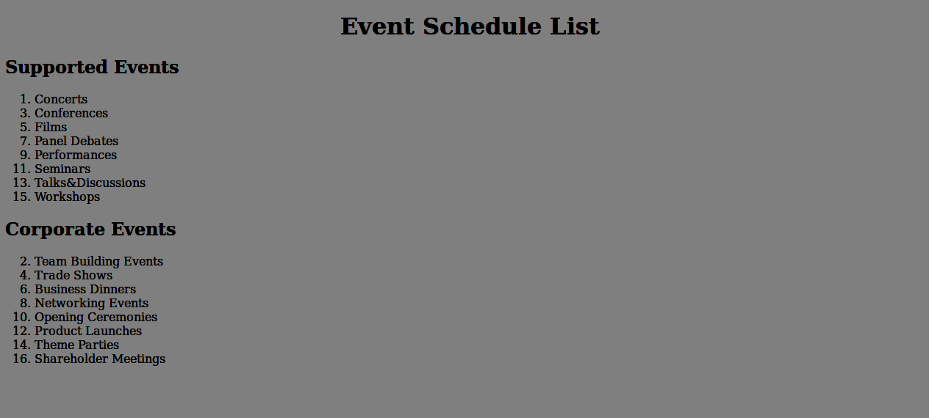  
  
Sample Screenshot 2 :  
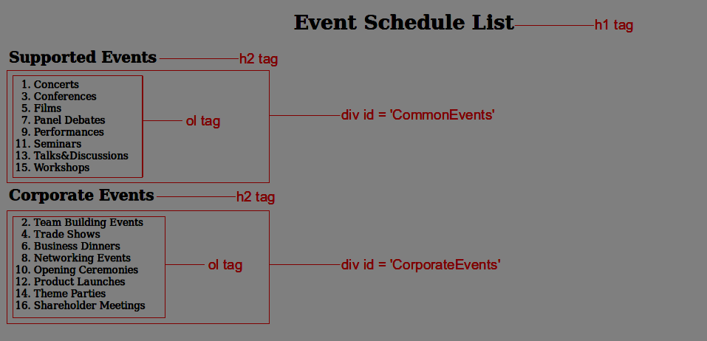  
  
Sample Screenshot 3 :  
